Coordinator screenshots
Data entry fields for entering a completed milestone and a completed expense

Data entry fields for entering a new subject and adding a new document.

Screenshot of report of subject summary report. This can be filtered by study as well.

Rogue has the capability of tracking the progress and quantifying the length of time it takes for projects to move from CDA to Open

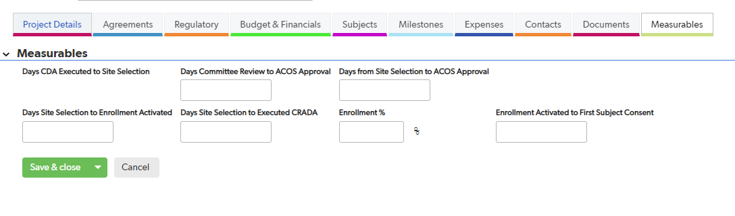

Your accounting department can run a report showing transactions entered but not invoiced.
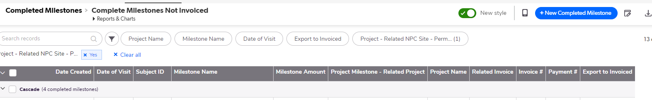

Details are organized for easy reference:
This is view of the “Contacts” Screen, it’s easy to keep details organized. The next tab, “Documents” also helps by keeping all study related documents organized and easy to find.
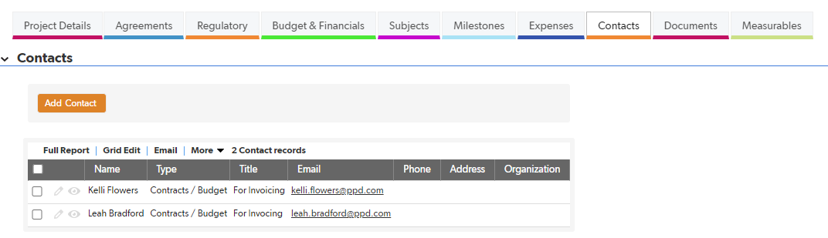

Invoices and payments are easily tracked and displayed:
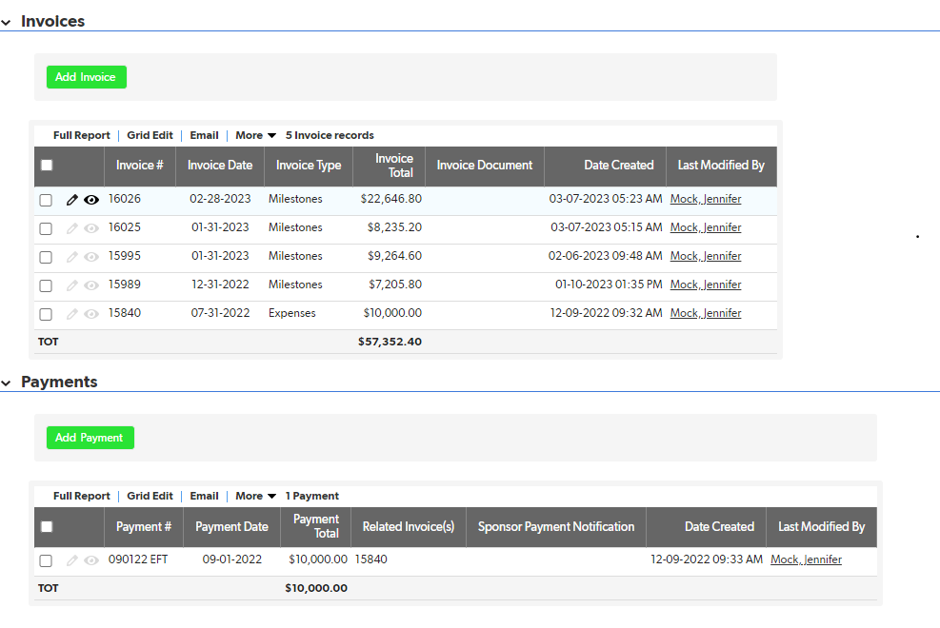

Reporting is flexible: an example below shows that reports can visually display projects by status. Users can easily pull data in reports specific to user needs, download to excel, or save as PDF’s for backup documentation.
